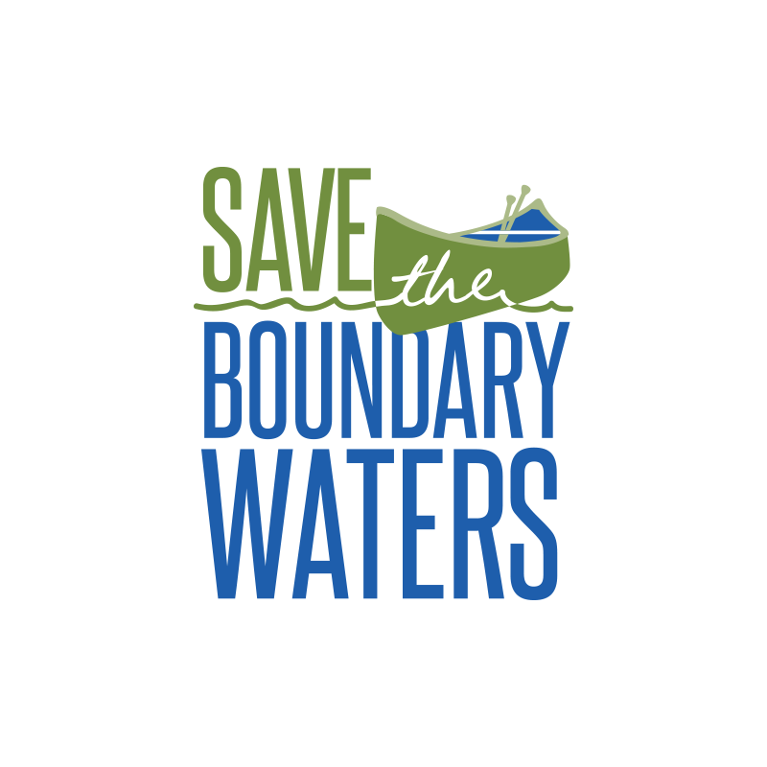November 3, 2020

Northeastern Minnesotans for Wilderness

P.O Box 625

218-365-7808

[info@savetheboundarywaters.org](mailto:info@savetheboundarywaters.org)

Dear Friends of Wilderness Preservation,

Our community is bound by invaluable memories of canoeing, hiking, and unforgettable adventures along the Boundary Waters landscape. To ensure that our experiences may be accessible to future generations, it is our time to protect these lands and waters. We ask that you give us a minute of your time to consider the challenges we face. Copper-sulfide mining by foreign conglomerates creates a threat to our beloved Boundary Waters and it’s surrounding landscapes. Together, we can help prevent the Chilean mine from destroying our beautiful Northeastern Minnesota landscape.

“Pollution from these mines will flow directly into the heart of the Boundary Waters”. Pollution from these mines are estimated to affect the wilderness for, at least, the next 500 years. Also, “along with the Superior National Forest, it contains 20 percent of all the freshwater in the entire National Forest System”. If we do not act now, the event horizon is near, or the point of no return, and it is imperative that we protect this wilderness from any mining threats that cross its path.

Bill 5598 (Boundary Waters Wilderness Protection and Pollution Protection Act) would help to protect lands and habitats from being destroyed by mining facilities. Getting such legislation passed would mean the protection of our land at all costs. Bill 5598 seeks to, not only preserve the environment, but also to establish a solid foundation for our economy.

We encourage that you contribute. Please visit our instagram page; where you will find ways you can get involved, the option to sign our petitions, information to donate, and other volunteer opportunities. Your donation of just $5, will go towards educating legislators about the upcoming bill, and provide them with the information they need for their vote. Larger donations will go towards educating others about Bill 5598.

Please visit our website <https://www.savetheboundarywaters.org> for further information or to donate.

Sincerely,

Your fellow friends at Save the Boundary Waters

*P.S. Be sure to sign up for our Newsletter to stay informed and in the know about the progress we are making to “Save Our Boundary Waters”.*